 | CSCI/ISAT B104  Computer Programming Techniques, Practices, and Tools  Fall 2026  Project Documentation  Team XX

Contents
Project Contributions by Team Member 2
Collaboration Tools 3
YRBS Questions Explored 4
YRBS Demographic Information Explored 5
Research Question 6
YRBS Data Winnowing & Retrieval 7
Bibliography 8
Acknowledgements 8

Project Contributions by Team Member

Members and their Contact Information
Member | Email | Text
Frankie | fsacco@uscb.edu | 8435054041
David | dheitman@uscb.edu | 2065194233

Overall
Relative Contribution of each member over the course of the entire project

Member | Contribution | Total Hours
 | %
 | %

YRBS Question Identification & Documentation
Member | Contribution | Hours | Components
Frankie | 50 % | .5
David | 50 % | .5

YRBS Data Winnowing & Retrieval
Member | Contribution | Hours | Components
 | %
 | %

Data Analysis (via Python)
Member | Contribution | Hours | Components
 | %
 | %

Data Visualization (via Python)
Member | Contribution | Hours | Components
 | %
 | %

GUI Creation (via Python)
Member | Contribution | Hours | Components
 | %
 | %

Python Script Creation
Member | Contribution | Hours | Components
 | %
 | %

Research Poster Design & Preparation
Member | Contribution | Hours | Components
 | %
 | %

Presentation Preparation & Practice
Member | Contribution | Hours | Components
 | %
 | %

Project Documentation & Administration
Member | Contribution | Hours | Components
 | %
 | %

Collaboration Tools
Tools to assist with task management, version control, communication, etc.

YRBS Questions Explored
Questions & responses explored over the course of the project.

Place screenshots of the two questions below. Be sure to include their “response keys”.

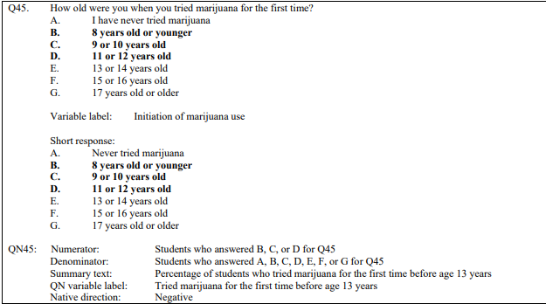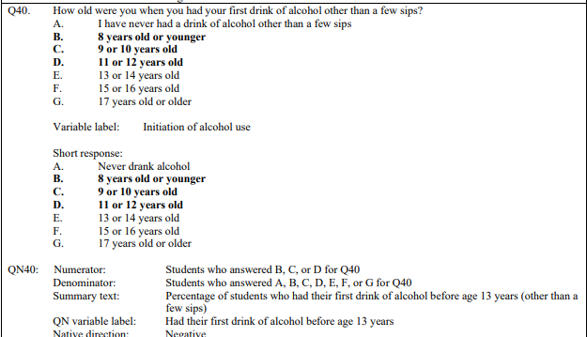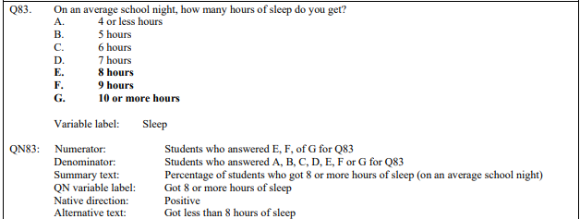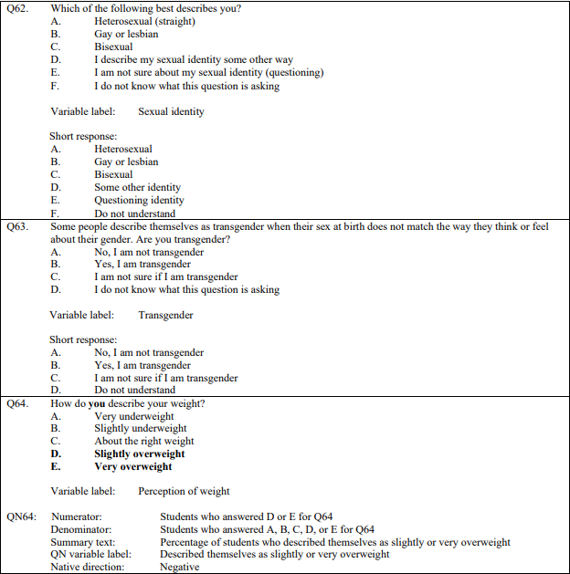

YRBS Demographic Information Explored
Demographic questions & responses explored over the course of the project

Place screenshots of the questions below. Be sure to include their “response keys”.

Demographic information includes gender, age, height, weight, ethnicity, etc.

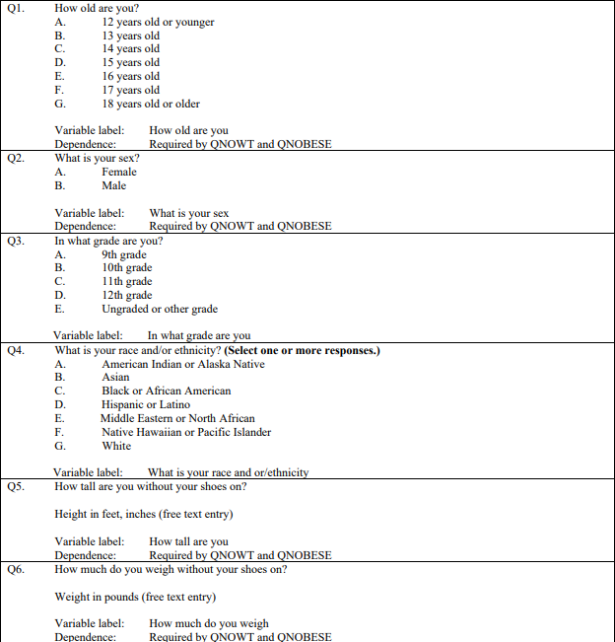

Research Question
The specific research questions we sought to answer.

Write down your research question here.

Among U.S. high school students, is more frequent social media use associated with getting fewer than 8 hours of sleep on an average school night.

Are students who first tried alcohol or marijuana before age 13 more likely to be current users than students who started later?

YRBS Data Winnowing & Retrieval
How we winnowed & retrieved the data explored over the course of the project.

Write down a step-by-step guide explaining how you winnowed & retrieved the data from the YRBS site.

Place screenshots of the SQL code and other relevant details here

SELECT Q1, Q2, Q3, Q4, Q5, Q6,
Q45, Q40, Q83, Q62
FROM XXHq
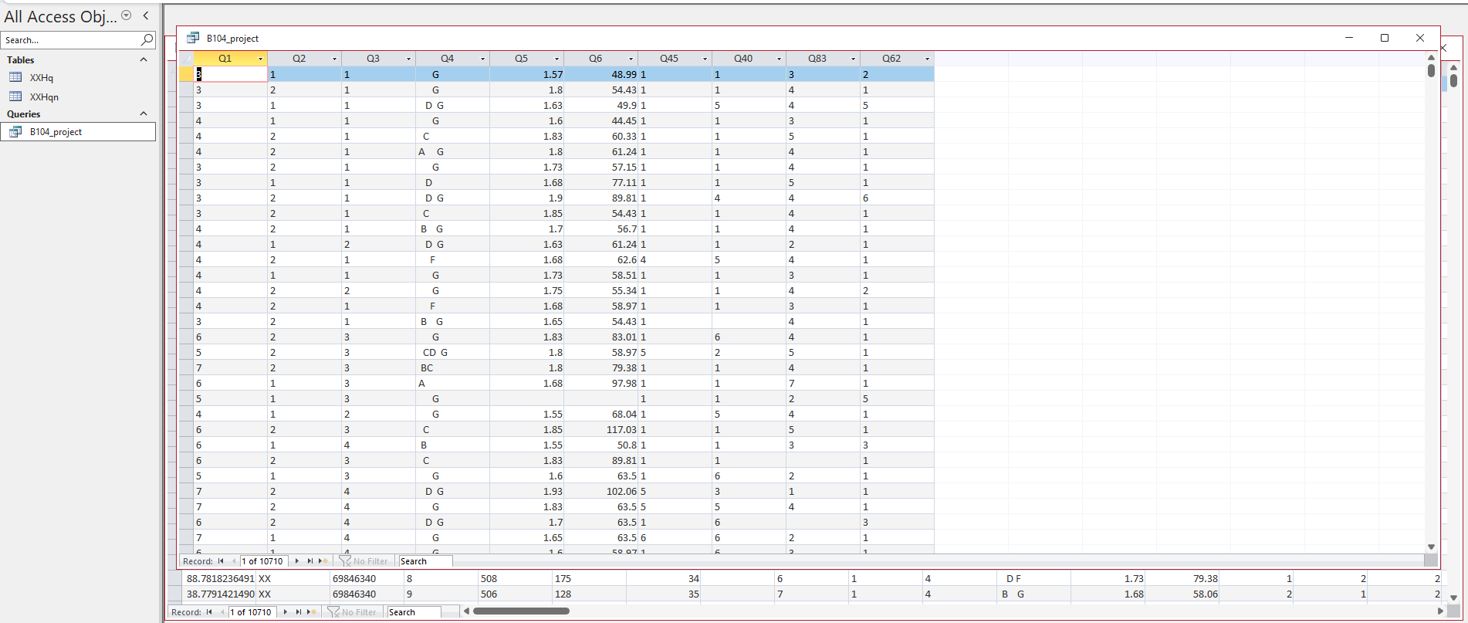

Bibliography
Resources which we used over the course of the project.

Citations for:

Python Library Documentation
Python Tutorials
Best Practices
Poster Templates
Stack Overflow questions/answers
Etc.

Follow APA format

Acknowledgements

Specific peers who helped you debug
Upper class students, parents, siblings, friends, etc. who provided feedback and guidance
Etc.

